**Brake System**

List of parts:

* Haydon Kerk Non-Captive Linear Actuator
  + Part Number: 57F4A-3.25-099
* Willlwood 5/8” Bore Master Cylinder
  + Part Number: 260-3372
* Arduino Uno
* Cable for Arduino
* Stepper Motor Driver
  + Microstep Driver ST-4045-A1
* AGS Poly Armor Brake Line
  + **Part Number:** PABX-340
* Tolomatic H20 Hydraulic Disc Brake
* 2x Limit Switches
* Wires
* Threaded aluminum block connector (to fit m6x1 and 5/16-24)
* Power Source (30-40 V)

List of tools/items:

* ¼” combination wrench
* 3/8” combination wrench
* Manual vacuum pump
* Clax (red clay-like substance)
* Adjustable wrench
* Urethane tubing
* Tapered hose adapter

Assembly: (rough outline)

1. Screw in the linear actuator and the pushrod of the master cylinder into the threaded aluminum block.
2. Screw the master cylinder into the brake line and tighten.
3. Screw the brake line into the disc brake and tighten (if disc brake is new, tapping required)
4. If not attached, attach the plastic reservoir to the master cylinder. Make sure the metal ring is on the bottom of the reservoir but lose. To attach the reservoir, heat the bottom of the reservoir with a heat gun to about 100 degrees Fahrenheit and then quick slide it onto the master cylinder. Tighten the metal ring with a Philips head screw driver.
5. Attach the master cylinder and linear actuator to bracket.

Wiring Diagram:

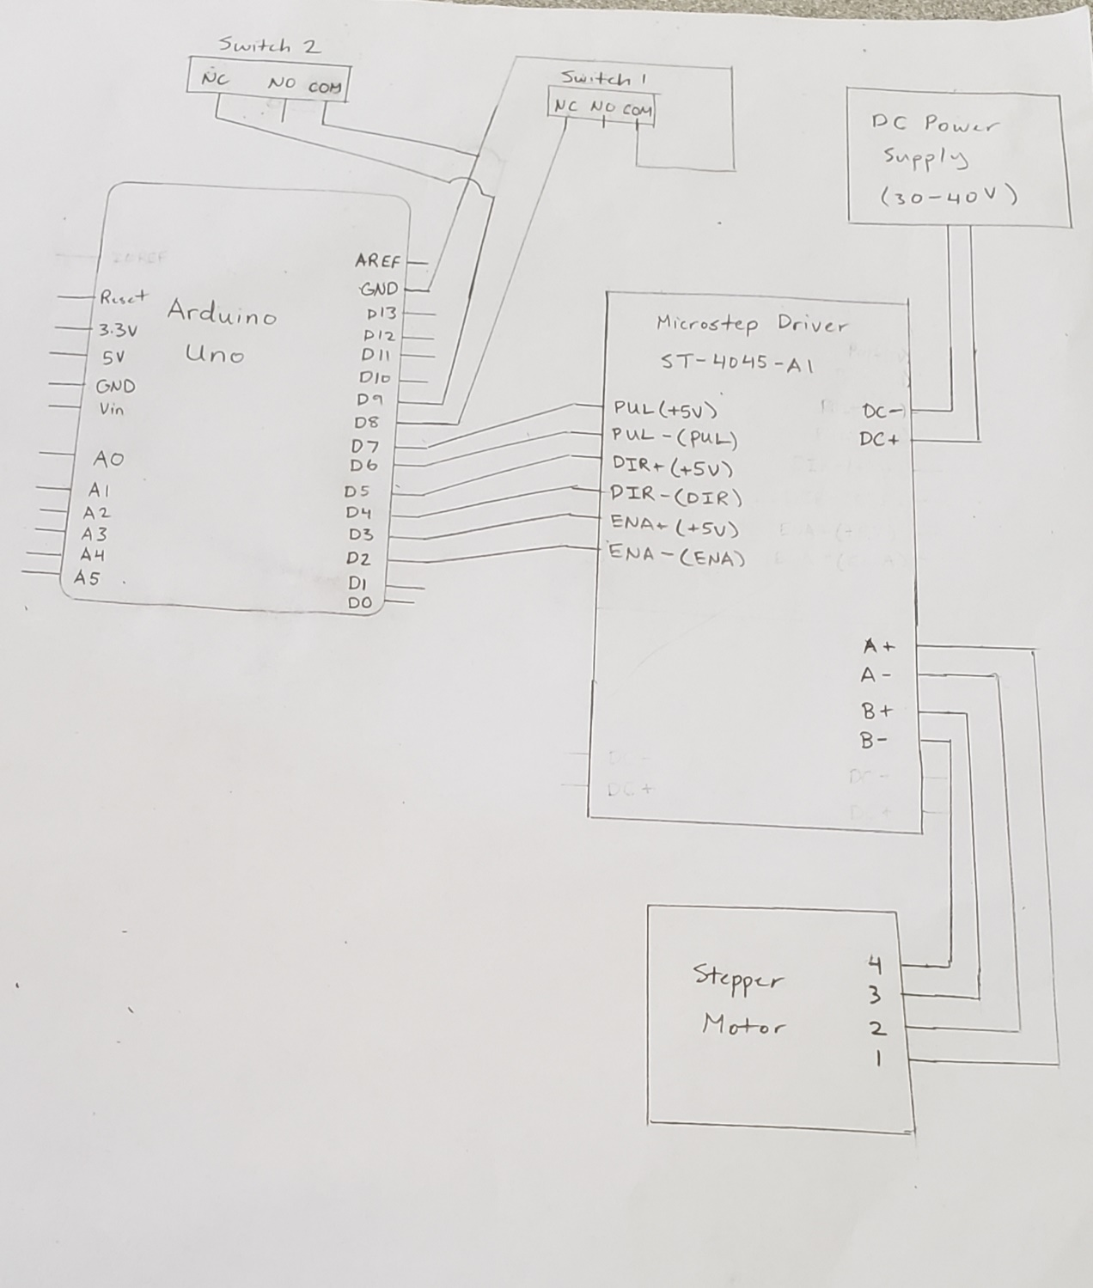

Brake Bleeding (requires 2 people):

1. Put on protective gloves
2. Fit the urethane flexible tubing onto the bleed screw of the brake
3. Attach the other end of the tubing to the reservoir jar and then attach another tube from the jar to a vacuum pump.
4. Unscrew lid of reservoir and fill it up with brake fluid over the minimum line but less than the maximum line. Screw the lid back on.
5. Open the bleed screw by unscrewing it a bit (1-2 rotations)
6. Create a vacuum no more than 5 mmHg using the vacuum pump. Pump occasionally to prevent the pressure from going to zero.
7. Put some clax around the bleed screw and around the tubing around the bleed screw. Then squeeze the clax and tubing around the bleed screw with your fingers. If not sealed properly, air bubbles will constantly appear in the tubing as the fluid is being pumped. Done properly, the air bubbles will eventually disappear from the tubing as fluid flows.
8. When there are no more air bubbles in the tubing, even out the pressure (set to zero) in the pump and tighten the bleed screw.
9. Remove the clax
10. (If brake fluid is clean) Pour the brake fluid in the jar back into the master cylinder reservoir.

Setup by Code:

1. Make sure the switches on the stepper driver are set to a current of 1.8 A and to full steps. (combination is on the top of driver)

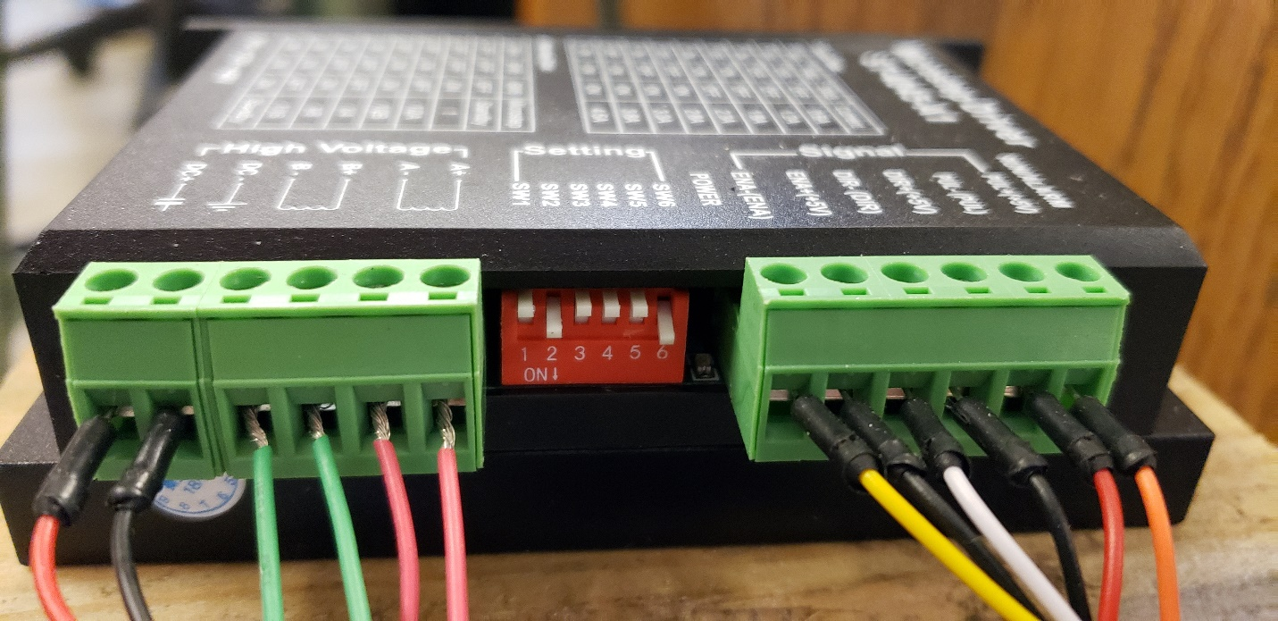

1. Fill master cylinder up with brake fluid.
2. Bleed brake system (See brake bleeding guide above)
3. Turn on the brake system. Zero the stepper motor.
4. Assuming a ¼ inch thick plate is in between the brake calipers, drive the stepper motor forward in increments of 100, 200, 500, 1000, etc. (does not have to be these values) until stepper motor cannot go any further when not stopped by switch. (Stepper motor will make loud/rattling sound when max force is).
5. Record number of steps of max compression for later use. (**Note: steps to max compression decreases slightly every time brake compresses**)
6. Drive the stepper motor backward until it hits the switch and then set the counter to zero.

Manual Setup (switches may need to be removed)

1. Make sure the switches on the stepper driver are set to a current of 1.8 A and to full steps. (combination is on the top of driver)

(insert picture)

1. Fill master cylinder up with brake fluid.
2. Bleed the brake system. (See brake bleeding guide above)
3. Detach the push block from the master cylinder. This can be done by twisting the pushrod of the master cylinder by hand.
4. Assuming a 1/4 inch thick plate is in between the brake calipers, pump the master cylinder until it cannot go any further at about ¾ of a full compression. Release the pushrod.
5. Screw the pushrod back into the push block.
6. Power up the brake system. Zero the stepper motor. Drive the motor 2000 steps forward and then in increments of 100 or 200 until brake is fully compressed. (Stepper motor will make loud/rattling sound when at max compression)
7. Record the number of steps for max compression for use later. (**Note: steps to max compression decreases slightly every time brake compresses**)
8. Place switches back if removed.

(pictures)

Code Guide:

*The step count does not work in the negatives. Set counter to zero or 10000 before using again.

*It takes around 2000 steps to get to the midpoint of a fully compressed master cylinder

*It should take around 2000 steps to get to max compression if brake caliper is completely open; less if partly closed.

List of Commands:

* xon -turns on the driver (default is on)
* xoff -turns off the driver
* x+Number(0-60000) eg x1904 -to set next move steps
* mx -motor moves to next position based off value of x+Number
* s+Number(0-2000) eg s500 -to set Microseconds between steps (Can also be changed in the code)
* cdon -turns on position data when moving will increase time of step
* cdoff -turns off position data when moving
* zero -sets counter to 0
* ten -sets counter to 10000

How to use:

Use to command x+Number (eg x2000) to set the position you want based on steps (will need to add/subtract depending on what your starting step number is). Then use the command mx to make the motor move to that position. When reaching close to max compression of the brake caliper, compress the brake in smaller increments (100 or 200 step increments). Use the commands zero or ten to set the counter to 0 or 10000. (**Note: code does not work properly when the counter is negative**)